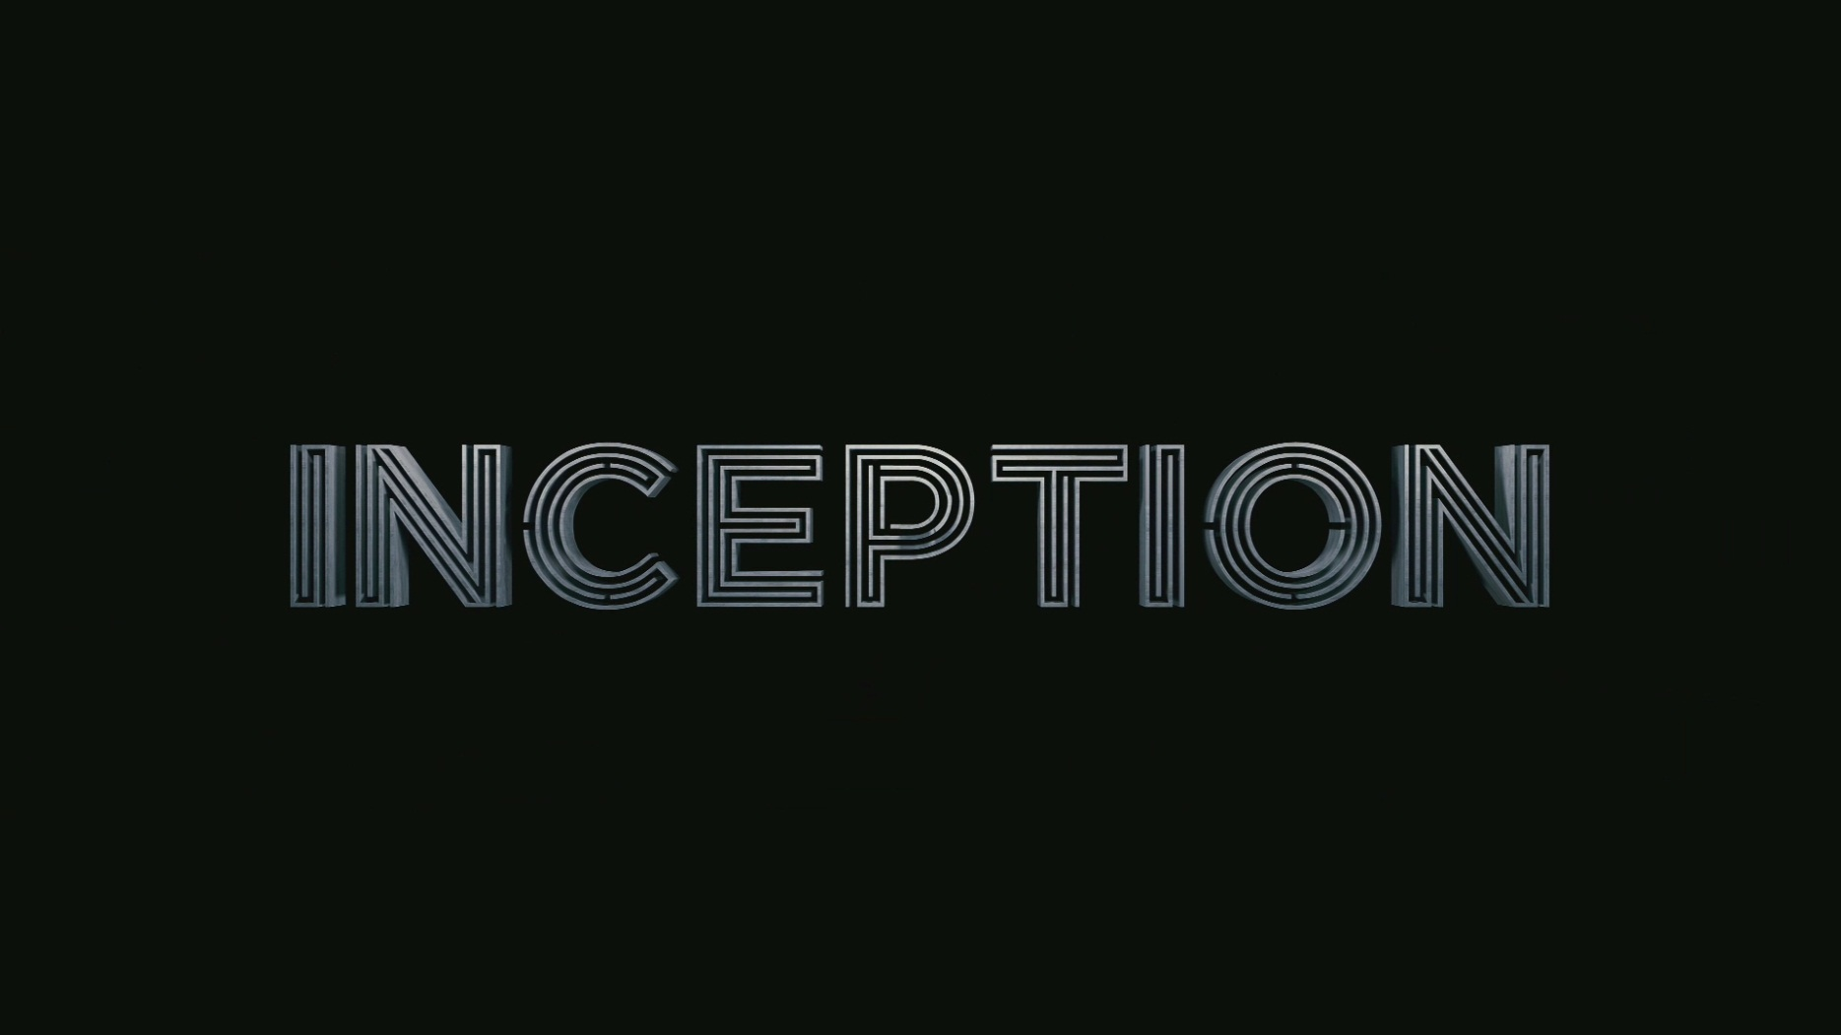

**An exploration of cell arrays and audio processing in MATLAB**

“An idea is like a virus. Resilient. Highly contagious.” Through the power of MATLAB, those ideas can manifest, and spread like the plague. Did you know MATLAB can be used for signal processing? It can, and we’re going to have some fun with this. We’re also going to have some fun with cell arrays. Why Inception? Can you think of a better cinematic example of things within other things? Never seen Inception? Watch it.

## In case you haven’t seen it.

What you need to know: Leonardo DiCaprio takes a cast list only Christopher Nolan can create and drags them down from reality into a dream that we’re going to call “van”, then they dream within that dream that they’re in a hotel, then within that they dream that they’re in this snow fortress, and then they dream that they’re in limbo. Basically, there are five levels including reality, and time slows down by a factor of 2^(n-1), where n is the current dream level. It’s 20 times slower in the movie, but that’s impractical for our purposes. We’ll just pretend the van is half speed, hotel is quarter speed, fortress is eighth speed, and limbo is sixteenth speed.

## Briefing

You must all work together on the various parts, but for the fun of it, you can see yourselves as three different roles: Architects, Forgers, and Extractors.

**Extractors**: You are going to be creating a main script that will manipulate/store necessary data and execute the work of the architects and forgers. You will be reading in a wave file of the song “Non, Je ne regretted rien” by Edith Pilaf (the “kick” song from the film). You will be shortening the song to a clip that goes from 0.5 to 5.75 seconds of the song, and you will be storing the left channel and the right channel of the audio into two separate vectors. Next, you will read in all 5 images of the 5 different dream levels (reality, van, hotel, fortress, limbo) and make a cell array containing the data. You’ll run the architect’s structure script and pause it for 10 seconds so we can see the pretty little plot. You’ll create a vector of the factor that each dream level “slows down”, and create a vector of the new sample rates of the audio clip so that you can play the clip at the 5 different speeds. You will also create a vector of level names for the forger. Lastly, you will create a loop running through 5 dream levels that makes an array of the appropriate dream level picture data, runs the forger’s plot program, and plays the sound clip at the appropriate speed for the dream level.

**Architects**: You are going to be creating a cell array named Inception that will build the dream levels from the movie: reality (1), van (2), hotel (3), fortress (4), limbo (5). These first four levels will be 1x3 cell arrays themselves. The first “element” will contain the next dream level down, the second will contain the name of the level, and the third will contain the level number. Limbo will still be a 1x3 cell as well, but the first element will simply contain a string that says “nothing is real”. You will create a new figure that’s larger than the default. You will graphically represent the cell array to see if it was defined correctly, and your script will save the MATLAB figure in the working directory.

**Forgers:** You will be creating a function that plots the different audio files at each of the 5 levels one by one (left and right audio channels) on a 5x1 subplot on top of the respective images for each dream level. This function will be looped through by the main script the extractor creates for each of the dream levels. You’ll need to create a new figure that is set up to be defined larger than the default. You will display the image in the subplot, and plot the audio signal on top of it. The left channel will be a green line, and the right channel will be plotted with a red dashed line. Each subplot will be titled with the respective level name.

## Summary

Your project is essentially three parts. A script that creates the cell structure and plots it (architect), a function that plots both channels of the audio signal of a dream level on top of the image for that dream level on a 5x1 subplot, a script that loads the audio file, creates the necessary variables for the forger, and loops through the forger’s plot function and plays the audio clip at the right speed for each dream level.

Here’s what your cell array is going to look like when represented graphically:

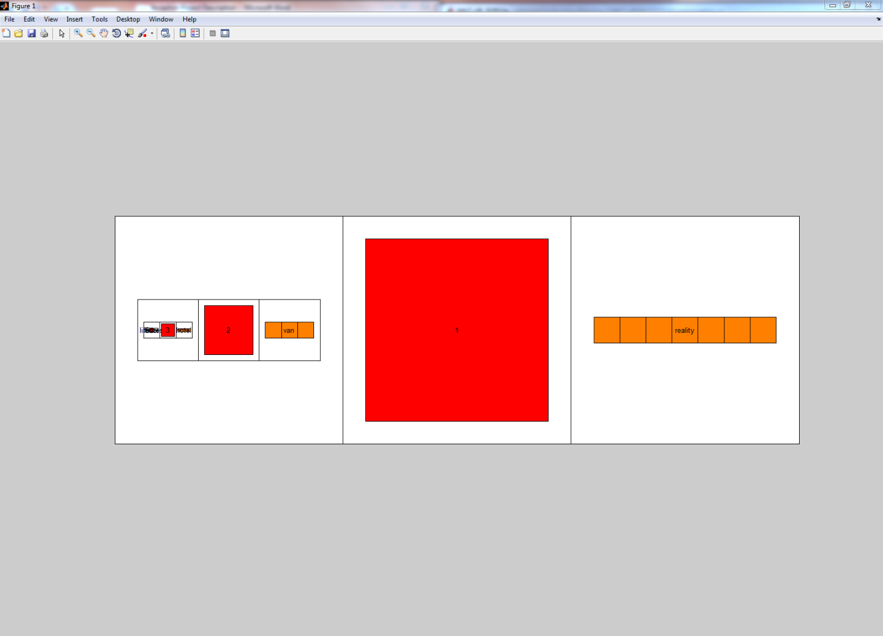

If you keep zooming in on the right into the next level, it looks like this:

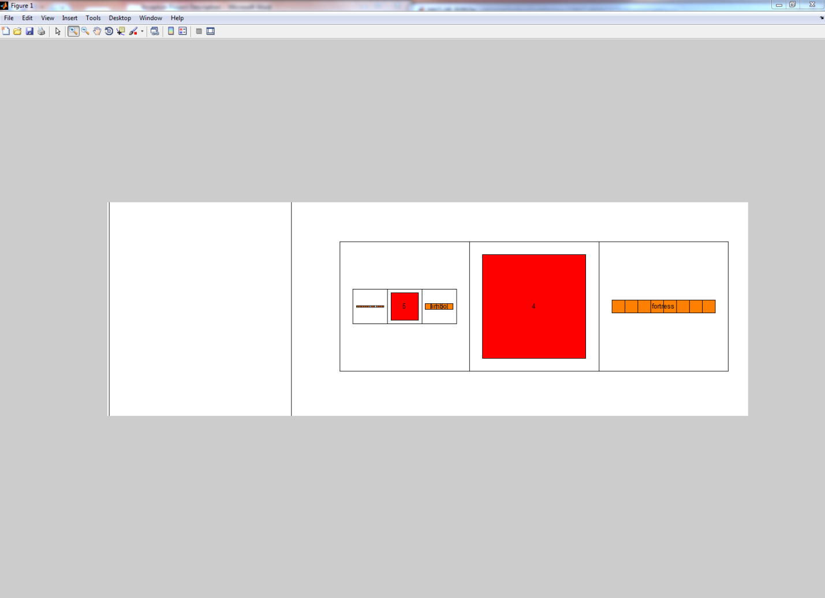

Your sound wave plot should look like this when the program is finished executing:

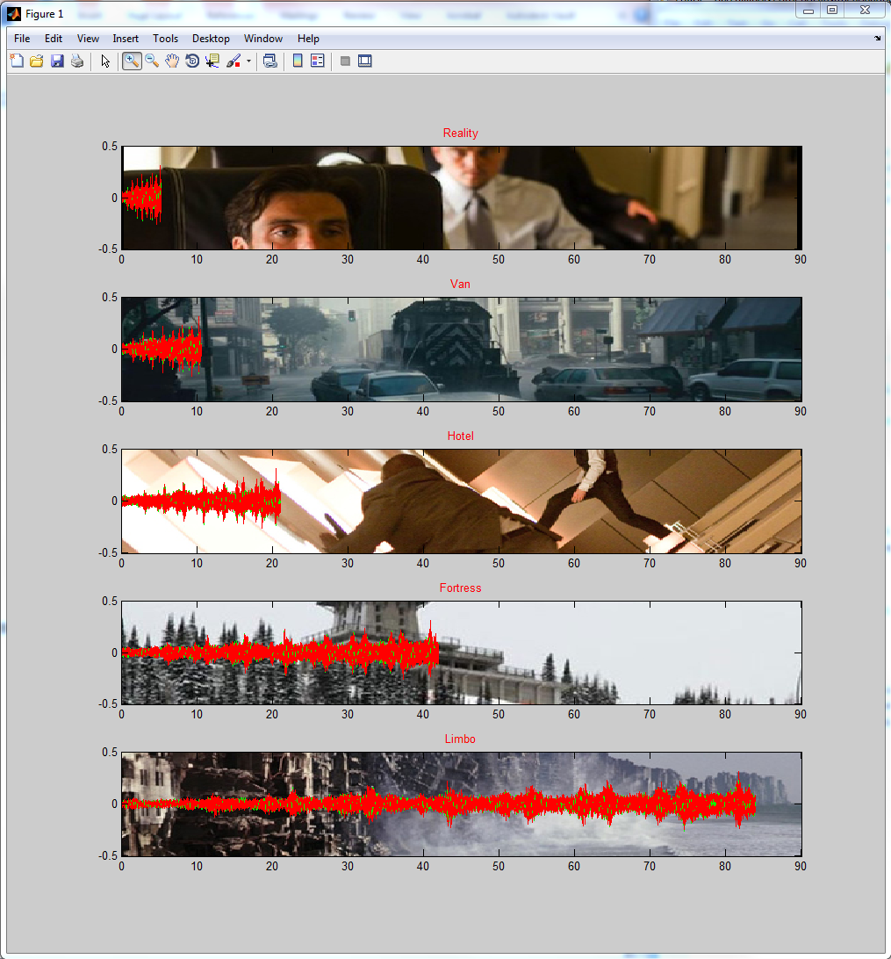

## Specifics:

### Extractors

* Resources you should maybe look at:

<http://homepages.udayton.edu/~hardierc/ece203/sound.htm>

* Functions you may want to look into:

imread()

* Your speeds you’ll have to use the sample rate (I’m not being generous, I’m making sure you do it right): 1 0.5 0.25 0.125 0.0625
* Really look into how to access data in cell arrays.

### Architects

* We don’t care how you can actually set it up, just make sure that it’s right.
* Graphically representing cell arrays is very easy.
* Set up the figure beforehand so that’s it’s larger (maybe 1000x1000 pixels, and position appropriately)
* Make sure the figure gets saved as a .fig when the script is run

### Forgers

* You probably want to look at <http://homepages.udayton.edu/~hardierc/ece203/sound.htm> as well
* This might be helpful (you don’t need to necessarily do what they did) <http://www.peteryu.ca/tutorials/matlab/plot_over_image_background>
* Set up the figure beforehand so that’s it’s larger (maybe 1000x1000 pixels, and position appropriately)
* Your function should not explicitly code all 5 levels; it is the extractor’s job to loop through it.
* I’ll go ahead and give you a hint on scaling your images in a way that also works for your scale of the audio signals:
  + Minimum x: 0
  + Maximum x: 90
  + And the difference in y minimum and maximum to be 1. We’ll leave it to you to figure out why this is stated so enigmatically.
* Your plot titles on each of the subplots should be the appropriate dream level (extractor is responsible for handing you off the right one) in red.
* Save your figure as a .fig